**1.Binary tree transversal problem**

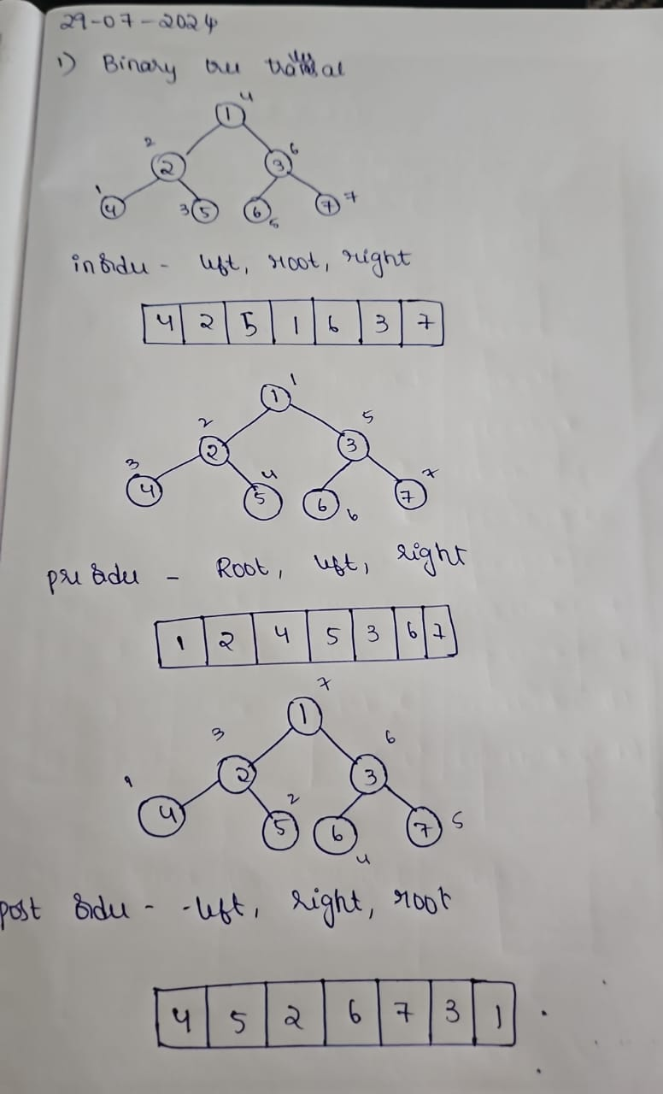

**2.Binary tree expression problem**

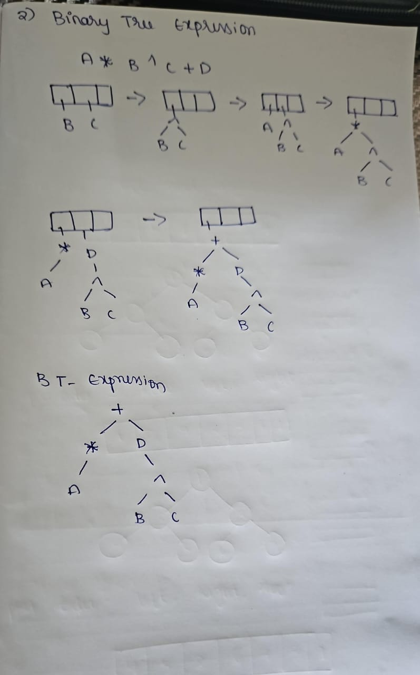

**3.Write a c program to find the binary search tree operation**

